institute for god’s remnants
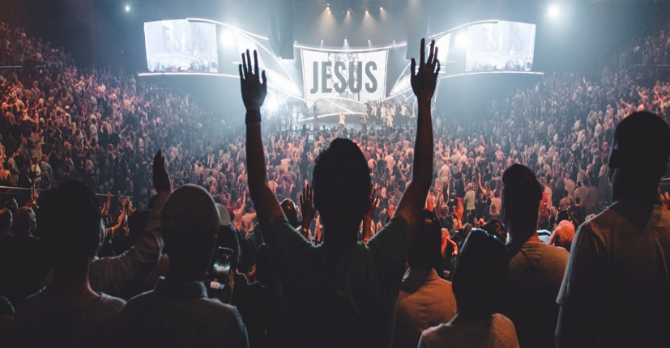
god | mission | authentic living

why i.f.g.r.?

Why not? it’s free, it’s online, and it’s safe!
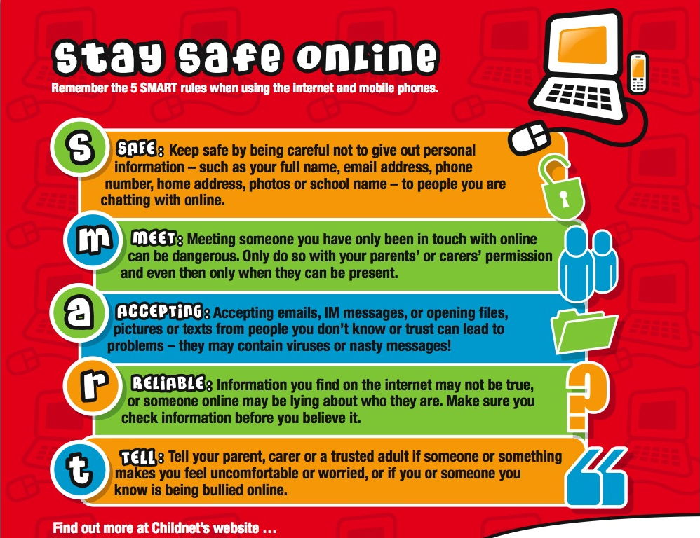 |  |  | Institute for God’s Remnants (I.F.G.R.) will create a safe, fun, and informative platform for your child aged 7 years -to 15 years old. The classes are secure sessions via Zoom Video Conferencing where the student can have an interactive peer group session learning the bible. The class assessments are not pass or fail; but, an assessment for each student to review material they may have missed for personal growth.  Note: The child has an option of not sharing their face and still participate in the class.  I.F.G.R. encourage the students to grow spiritually through learning God’s Word and applying it. I.F.G.R. is not interested in mere head knowledge for the youth, though it is of great importance; but, we desire they become the church that God has ordained from the foundation of the earth.  How does your student become a part of this new online movement?  - Go online to: https://shephardlei.wixsite.com/ifgr  - Complete:  - Online application  - Parental permission for student participation  - Download Zoom app. Login from your computer, tablet, or smartphone  Video/Phone Information:  Meeting ID:  Password:  - The child attend course on specified date and be prepared to engage in class activities.
In our discipleship course, we will teach fundamentals of the Holy Bible, prayer, salvation, and discipleship. We are a Word based, and not denomination-based organization. I.F.G.R. mission is not to create a new generation of religious church goers; but, a generation whose lifestyle reflects devotion to God. As the Lord leads, the instructor will request students to display Fruit of the Spirit (Galatians 5:22-23) [love, joy, peace, patience, kindness, goodness, faithfulness, gentleness, and self-control] in a community or family environment. If you have any concerns or questions, contact: askteacherlei@gmail.com or text 832-775-3678 subject line: IFGR STUDENT/PARENT QUESTION:

